**DBMS Project**

**Key Milestone II:  Normalized Relational Schema**



**Spring-22**

Submitted by:

**Amir Suliman 19pwcse1805**

**Ashfaq Ahmad 19pwcse1795**

**Mansoor Hussain 19pwcse1858**

Class Section: **B**

“On my honor, as a student of the University of Engineering and Technology, I have neither given nor received unauthorized assistance on this academic work.”

Submitted to:

**Engr.Sumayyea Salahuddin**

June 10, 2022

Department of Computer Systems Engineering

University of Engineering and Technology, Peshawar

1. **Relational Schema**

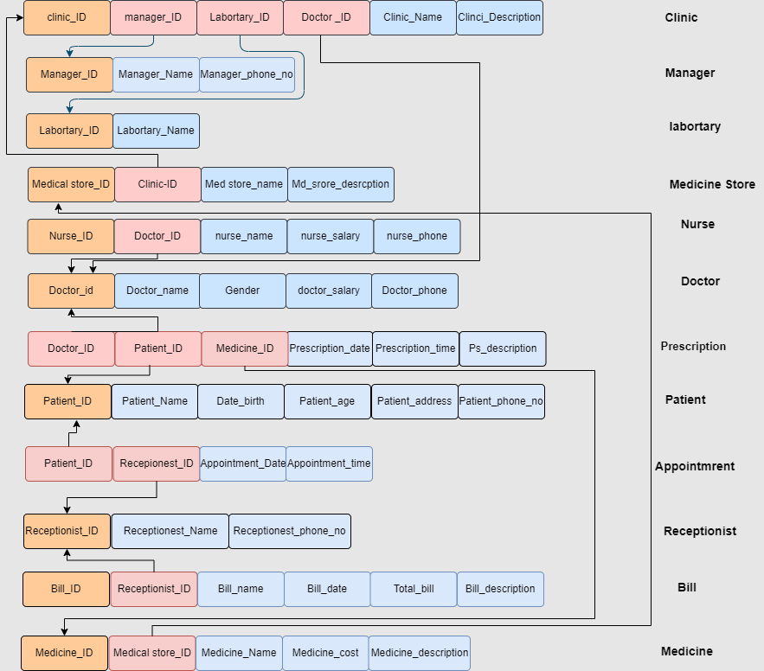

1. **Normalization**

**1st NF**

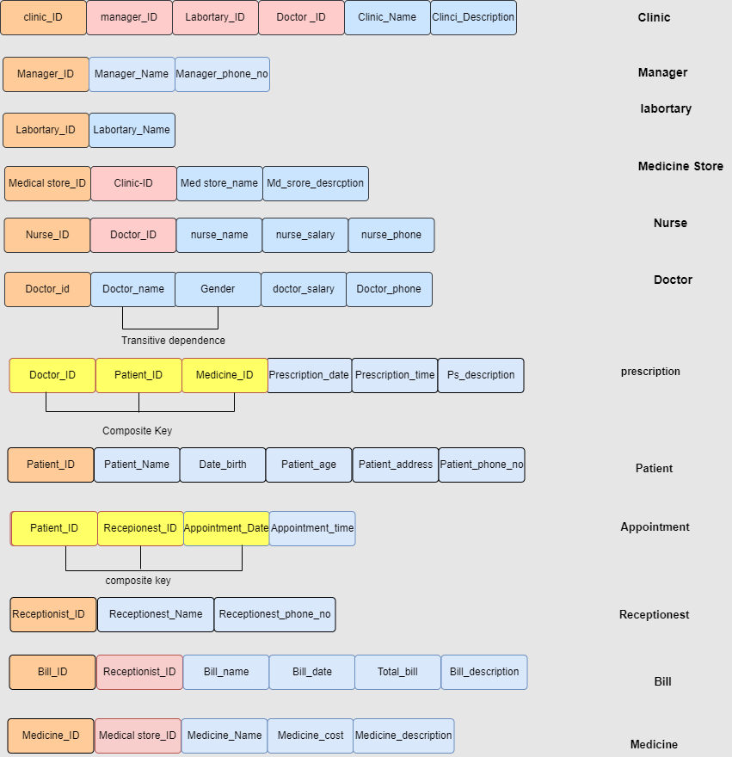

**2nd NF**

* 2nd NF is already done in 1st NF

**3rd NF**

